**Joomla Project 01 Concepts by Ilyas Nur and Rodwan Mohamed**

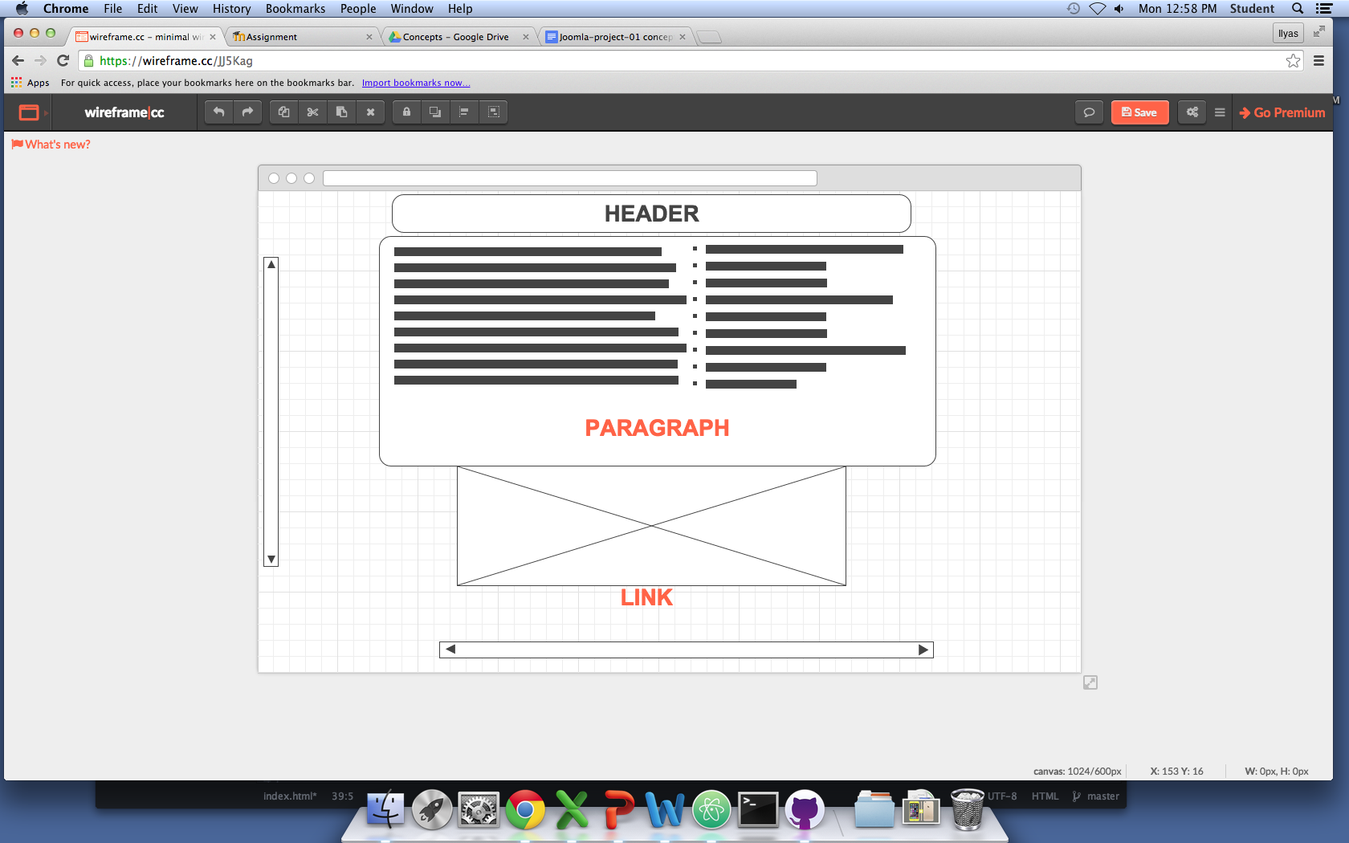

**WireFrame**

**We are selling TV`s and our target market is adults 18 years and older.**

**The Color of the background is anthracite black. and The font color is black.**

**The concept of the web site is to convince the User of buying a TV.**